Candy Grabber

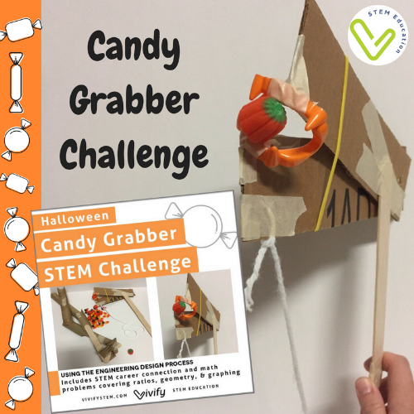

The local candy factory has had a major spill! We need your young engineers to help clean it up. This challenge is designed for the classroom or homeschool group where students go through the engineering design process in teams. Each team creates a device to grab candy from a given distance. Successfully pass the test by picking up candy with your device, and save Halloween! *Note: optional pages are included that omit the word “Halloween” if desired.

This challenge includes:

Detailed teachers guide with links to resources
Grading Rubric
Handout teaching the concept of levers
Student handouts to guide them through the engineering design process
Student recording sheet for each step of the process
Math connection problems including areas, percentages, and graphing (With an answer key) in both American customary and metric units

If you are looking for candy ideas for this challenge that will be safe for kids with allergies, check out this helpful website!

Pumpkin Seed Friction Experiment

The goal is to pour pumpkin seeds into a bottle such that you can lift the whole thing by a pencil or stick that is inserted into the bottle. Here is what you will need:

· Pumpkin seeds

· Pencil or stick

· Medium sized plastic or glass bottle

Now here is what you do:

1. Ask the question: “Do you think I can lift a bottle of pumpkin seeds with a pencil/stick?” Whether they say “yes” or “no” have them justify their answer to get their brains warmed up to critical thinking.

2. Place the pencil/stick into the bottle

3. Slowly add pumpkin seeds until the bottle is full

4. Bang the bottle gently in your hands to settle the pumpkin seeds

5. Add more pumpkin seeds if necessary (more room may have been created after the previous step)

6. Place the chop stick into the bottle

7. Hold onto the pencil/stick and lift it up slowly. The pencil/stick should stay securely in the pumpkin seeds and the bottle should rise with it. (the pumpkin seeds may need to be packed in more tightly if this does not work)

8. Ask “What is going on here?”

The Science

Friction is the resistance something experiences as it moves against another object. In other words, it is a force that opposes movement. When you pull up on the pencil there is frictional force between the pencil and all the surfaces of the pumpkin seeds it is touching. This interaction is preventing the pencil from slipping out of the bottle. In this case, the frictional force is so great due to the packed-in nature of the seeds, that you are able to pick up the entire bottle by just the pencil as if everything inside the bottle were glued together.

