5 Life Science STEM Activities

vivifystem.com/blog/2019/4/22/5-life-science-stem-activities

Vivify STEM April 23, 2019

Butterfly Fliers
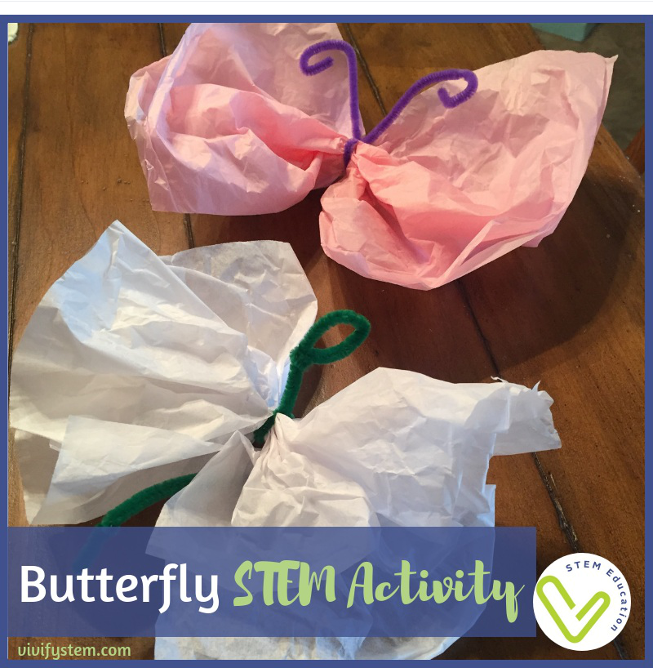

Investigate drag and butterfly flight with this butterfly STEM activity.

Another beloved pollinator is the beautiful butterfly. But what allows them to fly they unique way they do? Watch this video by Inside Science to learn the physics! For our STEM activity, we will focus on the glide and drag of a butterfly’s colorful wings.

Ever wonder how butterflies use their wings? See here to find out.

You will need: Pipecleaners & tissue paper. Use a stopwatch or phone timer as well.

The Challenge: Create a butterfly that will remain in the air for the greatest amount of time when dropped from a given height.

Set a height for students to drop their butterflies from, like the top of a doorway. Provide one sheet of tissue paper and one pipecleaner to each child. You may show them how to pinch the middle of the tissue paper, bend the pipecleaner in half around it, and twist it on the other end to form the butterfly’s body. Have students test different size and shaped wings to see which configuration stays in the air the longest. Record results and compare between students!

What do bees and butterflies both love? Flowering plants of course! Go further with the learning experience with a challenge that focuses on the science of plant development and an engineering design project— The Botany STEM Challenge. Create window greenhouses to grow live plants, learn about the pioneering botanist, Dr. Katherine Esau, and design a device to transport the little plants home. To read more about this challenge, go to our post here.

